Wild Oats Band
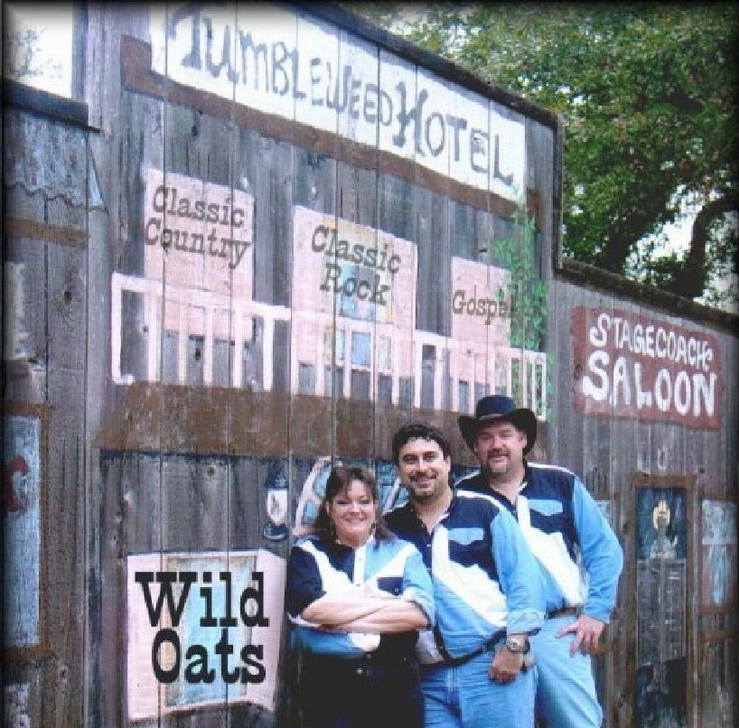
Wild Oats has been together for over ten years. We are called the "Been There Done That" Band because. everyone in the band is over 45 years old and by that time in your life you have usually been there and done that! Wild Oats is a Classic Rock and Classic Country Band with the services of D.J. if needed for any gig.

Call 210-415-7712 for booking times and prices.

David Fernandez has been playing drums since the age of six. He belnds in well with the Wild Oats sound. He is single and available girls!

Wes Capes has been playing bass since 1998. He is also the bands D.J. and sound man. They call him The Funky White Boy.

Lori Capes has been playing guitar and singing since she could stand up. She loves all types of music and also does a stand up impressionist act 1 hour before Theatre Opening every night at The Stage Theatre House in Bulverde. Call 1-830-438-2339 for tickets pricing and show times.

Wild Oats is pleased to be asked to play for the second year for the Converse Veterans Jubilee. Call for bookings and prices for your wedding, party, anniversaries or any other special events you may have to plan!

Special music and songs are available upon request.

