3rd Annual

Spring Jubilee
To Benefit
The American Legion, Post 593
326 West Legion Drive, Converse, Texas 78109
(210) 658-1111 / www.Post593.org
What:  - Live Bands and Entertainment  - Carnival Rides and Games  - Food, Soft Drinks, and Beer Booths  - Arts and Crafts Booths  - Car Show  - Motorcycle Benefit Run & Show  - Chili and Bean Cook-Offs  - Large Raffle & Silent Auction  - Blood Mobile  - Face Painting  - Martial Arts Demonstration  - Dance Demonstrations  - Flag Disposal Ceremony  - Dunking Booth and Much More!!!!  May 28 - 30, 2010  Friday: 5 pm - Midnight Saturday: 10 am – 1 am  Sunday: Noon – 6 pm | Where:  Converse City Park  Converse, Texas  When:  Friday, Saturday, Sunday  May 28 - 30, 2010  Why:  To Raise Funds to Support  Our Post & Programs  Kickoff Parade!  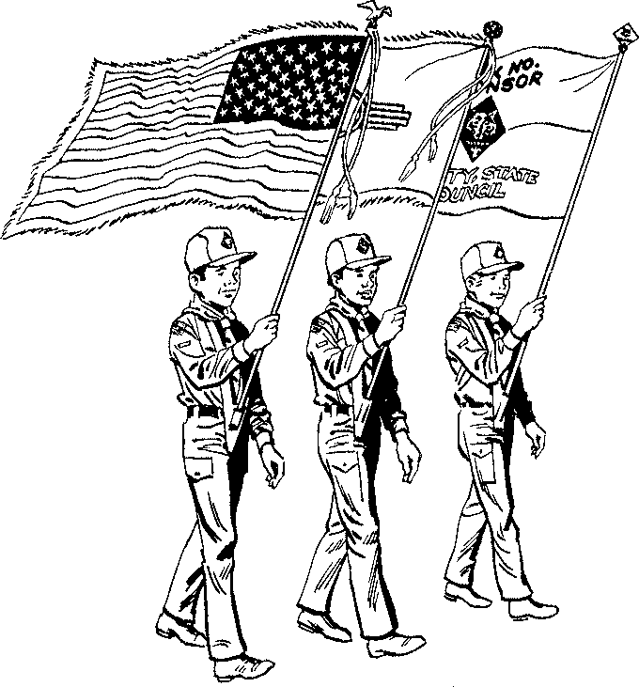  Saturday, May 29th, 2010  10:00 a.m.  Downtown Converse
Open to the Public!
Free Admission, Parking & Bands!!

******************************************************************************************
Call or visit our website today to reserve your food concession or vendor booth!
Call or visit our website to sign-up for the Parade, Car Show, Motorcycle Show,
Motorcycle Run, or the Chili Cook-Off!
For More Information Call (210) 658-1111
Visit our website at: http://www.Post593.org

