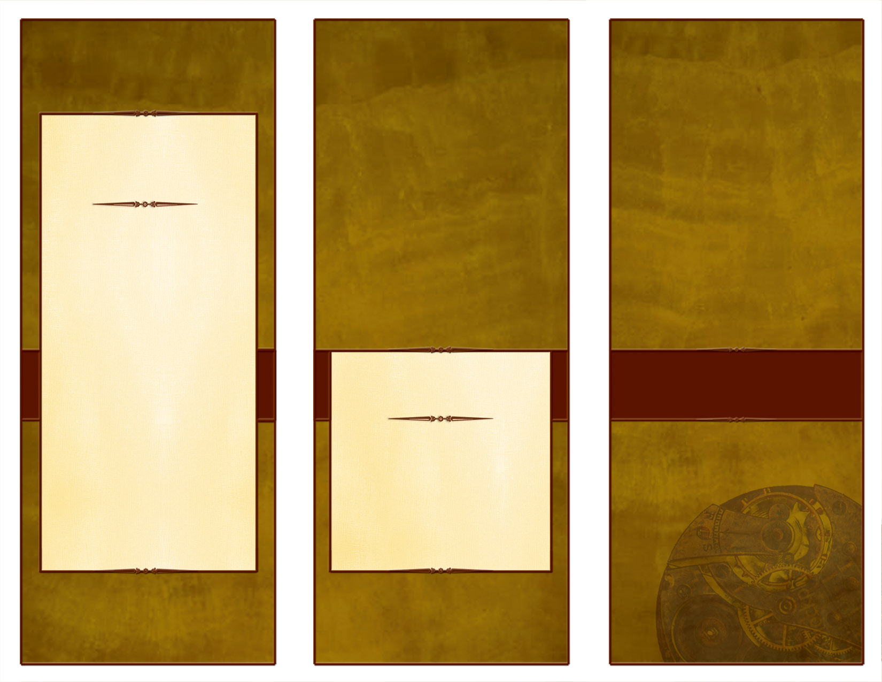
The American Legion
William M. Randolph Post 593
326 West Legion Drive
Converse, TX 78109

Ph (210) 658-1111

www.Post593.org

Email: Post593TX@yahoo.com

Our American Legion Post is raising funds and we need your help. Within these pages you will find several, but not all, of the programs we support. Please take the time to look through this material and decide to help us. Feel free to ask questions. We can use not only your financial support, but also your encouragement, time and talents. Our American Legion family includes Legionnaires, Auxiliary, Sons of the Legion, and Legion Riders. Consider this an invitation to become involved and make a difference in your community and in people’s lives. You’ll feel good about the difference you make.

American Legion Post 593

Converse, Texas

“We Put Converse on the Map”

We Need Your Help!
The American Legion
William M. Randolph Post 593

Please visit us on the web at www.Post593.org or email us at: Post593TX@Yahoo.com.
Thank you for taking the time to read this. We look forward to working with you in supporting our community together.

We Need Your Help

To Continue Our Service…

“Still Serving America”

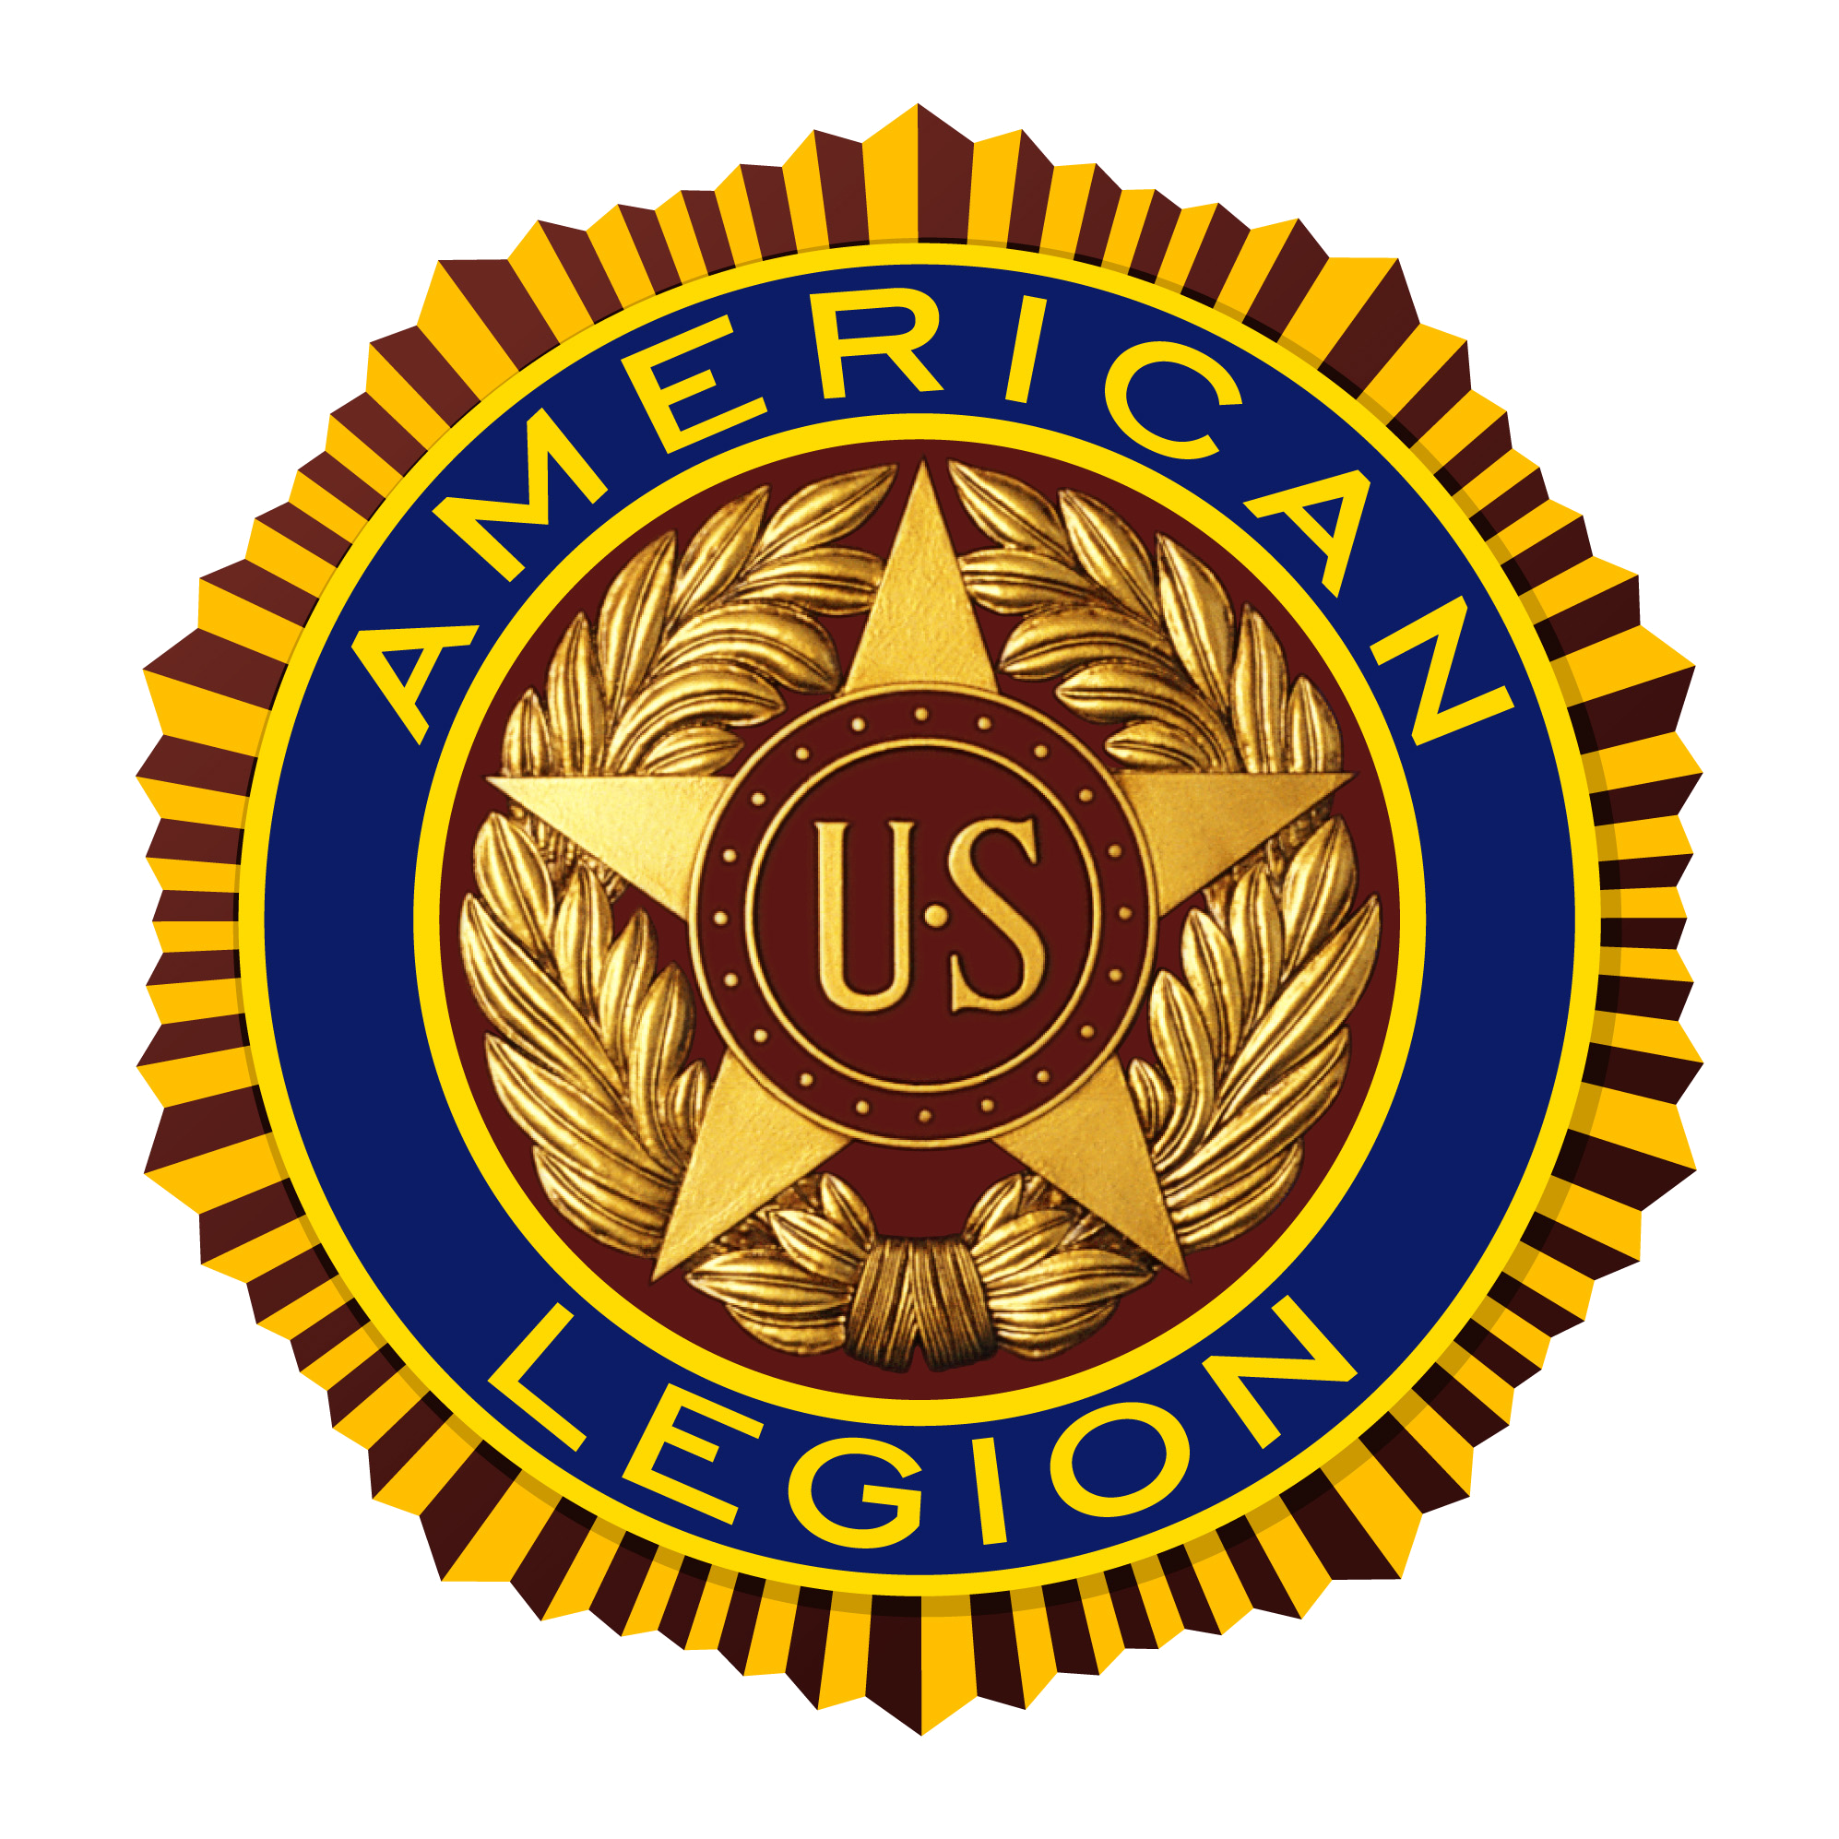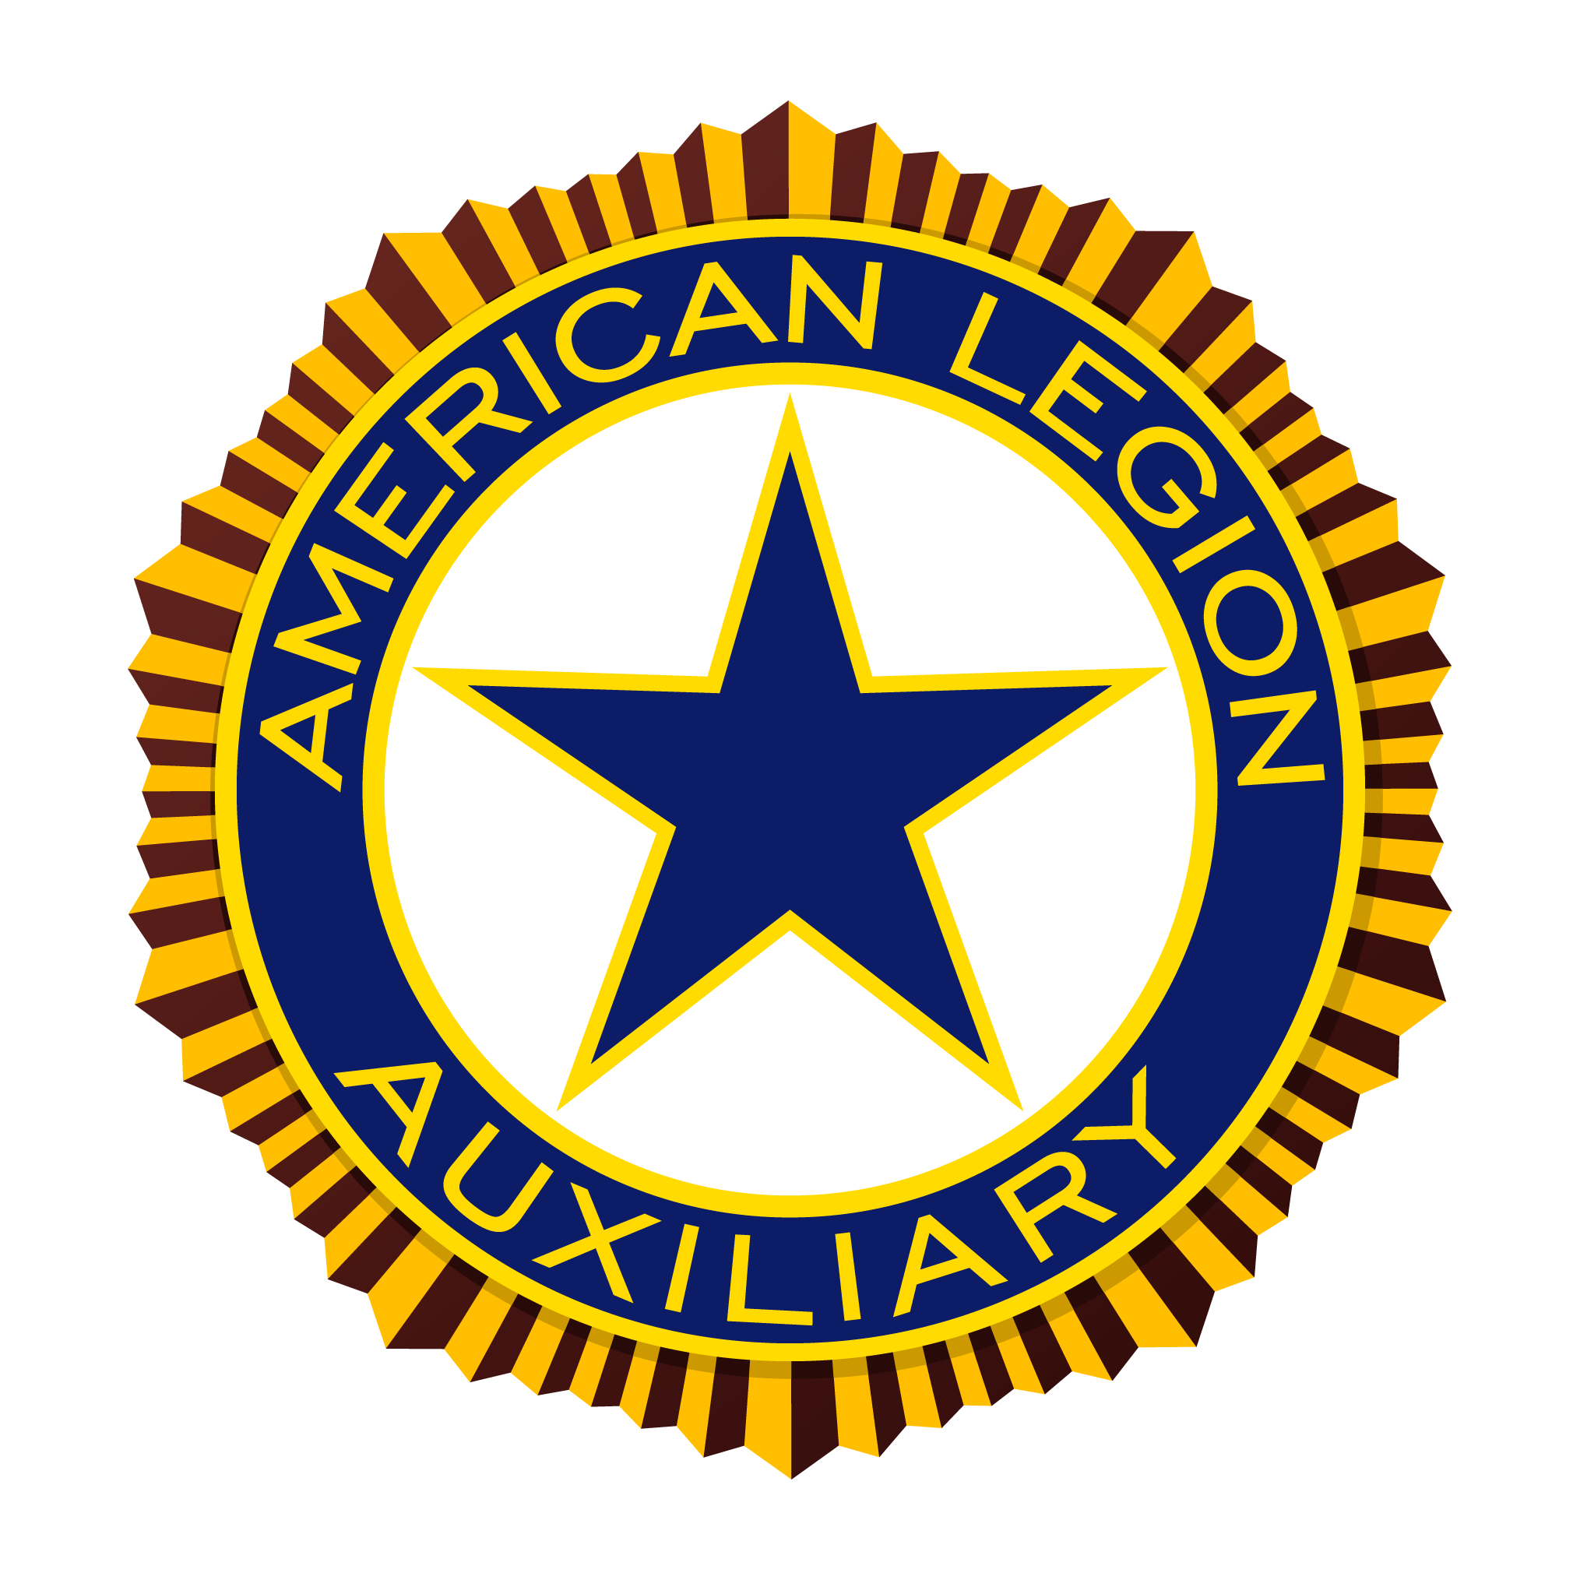

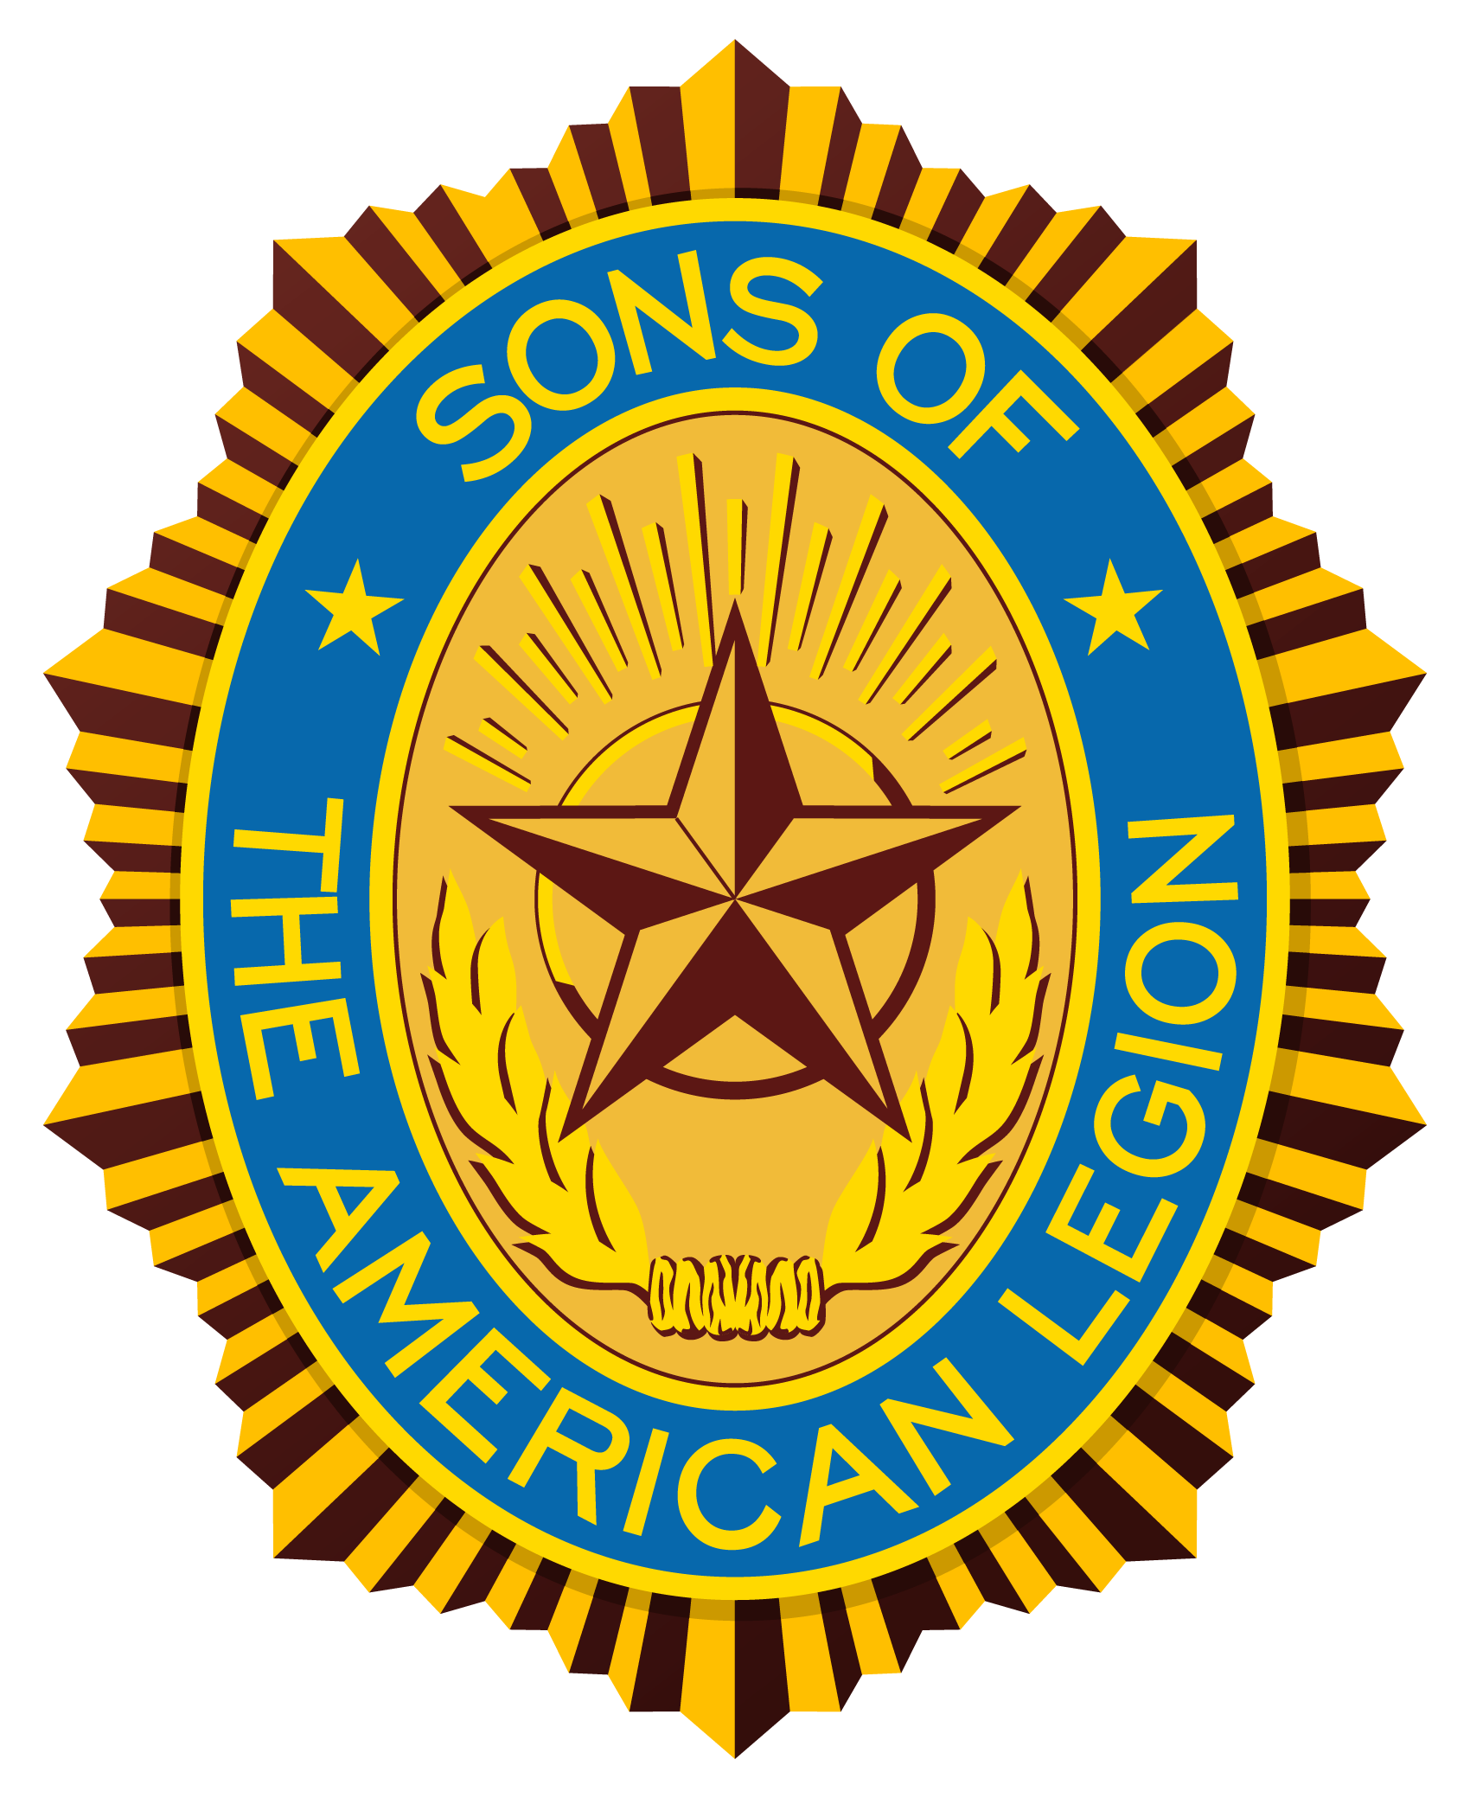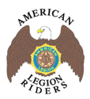
Our local American Legion Post is raising funds to help support our programs. The degree of success in this effort will determine the amount of outstanding support we may continue to provide to veterans, their families, and the local community. We are an extremely active Legion Post. In the last year alone we have donated over $60,000 and over 11,000 man hours to the local community. We have also provided the following services to the local community for more than 40 years:
- Veterans
  - Hospital Visitation
  - Soldiers Family Assistance Center (SFAC)
  - Lonesome Dove
  - Nursing Home Visitation
  - Legacy Scholarship Program
  - Fisher House
  - Operation Wounded Warrior
  - Patriot Guard Missions
- Neighbor-Helping-Neighbor
  - Boys State
  - Girls State
  - Oratorical Contest
  - Junior ROTC
  - Boy Scouts
  - Flag Program
  - Food Baskets for Needy
  - Scholarships
  - Adopt-a-Highway
  - Clothing Donations
  - Re-cycle Program
  - Parks and Recreation Assistance
  - Meeting Space for Community Organizations

Benefits to the Community:


