American Legion Post 593
Car Show
Saturday, May 9th, 2009
Converse City Park
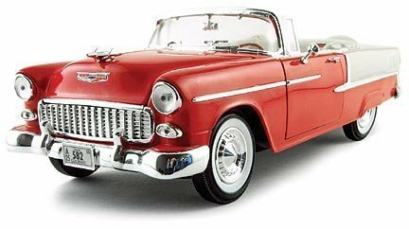
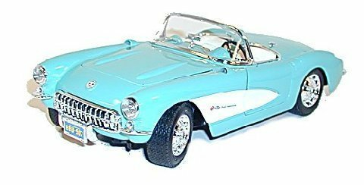

Class A: Antique Pre-49  Class B: Original Pre-89  Class C: Custom Pre-89  Class D: Street Rod Open  Class E: Street Rod Closed  Class F: Street Machine  Class G: Muscle Car Hi Performance Factory Only  Class H: Foreign  Class I: Competition – Not Street Legal  Class J: Current – 1989 to Current | 
There will be Judging for Best of Show and People’s Choice Award. Each Category Will Have a 1st and 2nd Place Winner.  Gates for car show open 9:00 a.m.  Registration will close at Noon  People’s Choice Votes will be .25 cents each or 5 votes for $1.00 | Sponsored By:  American Legion Post 593  326 West Legion Drive  Converse, TX 78109  (210) 658-1111
Visit us on the web at: www.Post593.org
LEGION JUBILEE CAR SHOW REGISTRATION
Converse City Park
Saturday, May 9th, 2009
Make/Model/Year _________________________________________________________________________
Class ____________________________________________________________________________________
Name ____________________________________________________________________________________
Address/City/Zip ___________________________________________________________________________
Phone: ____________________________________________________________________________________

Please fill out this form and mail form & payment of $20.00
American Legion Post 593
c/o Sharon Rector
326 West Legion Drive
Converse, Texas 78109
210-659-8908
(Please Make Check payable to: Post 593 Car Show)

