
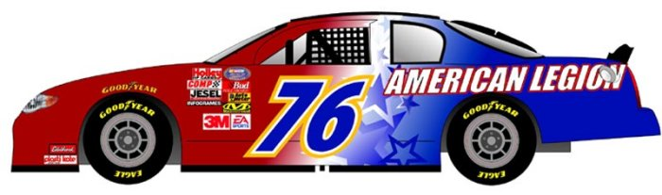
Legion Jubilee Schedule of Events
June 5—8, 2008
Converse City Park
Thursday, June 5th – 5 pm to 11 pm  Carnival, 5 pm to 11 pm  Friday, June 6th – 4 pm to 12 am  Carnival, 4 pm to Midnight  Live entertainment: 3 bands!!  Arts & Crafts Booths, 4 pm to 11 pm  Food Booths, 4 pm to 11 pm  Saturday, June 7th – 8 am to 1 am  Carnival, 1 pm to Midnight  Community Yard Sale, 8 am to 1 pm  (Gates open at 6 am for set-up)  Opening Ceremony at 1:00 pm  Arts & Crafts Booths, 10 am – Midnight  Health Fair, 10 am – 8 pm  Motorcycle Run, 1st Bike out at 10 am  Last Bike in at 3:30 pm  Motorcycle Show, Judging at 4:30 pm  Bike Run and Show Awards at 5:30 pm  Live entertainment: 7 bands!!!  Converse Pet Shelter, 10 am to 6 pm  Food Booths, Noon to 11 pm  Sunday, June 8th – Noon to 6 pm  Carnival, Noon to 6 pm  Car Show, Registration from 9 am to 12 pm  Food Booths, Noon to 5 pm  Face Painting, 12 pm to 4 pm  Health Fair, Noon to 6 pm  Arts & Crafts Booths, Noon to 6 pm  Martial Arts Demonstration, 1 pm to 1:45 pm  Dance Demonstration, 2 pm to 2:45  Fire Department Demonstration, 3 pm  Police Department Dog Demonstration 3:30 pm  Dunking Booth, Noon to 4 pm  Raffle Drawing, 5 pm  Flag Retirement Ceremony, 5:15 pm  Closing Ceremony, 5:30 pm | Band Schedule  Friday  6—8pm  Tina Y Grupo Tormenta (Tejano)  8:30-10:30pm  Ashlee Rose (Country Rock)  10:45—11:45pm  Jet City Rotation (Rock)  Saturday  Noon-1:30pm  Chad Johnson & Fiddler (Country)  2-3:30pm  Emmerson Biggins (Country)  3:45-5pm  3 Kisses (Pop)  5:15-7pm  Tina Y Grupo Tormenta (Tejano)  7:15-9:15pm  Playin’ Syx (Country)  9:30-10:45  Dick Wiggler & The Cattle Guard (Country)  11-12:45  Jet City Rotation (Rock)  