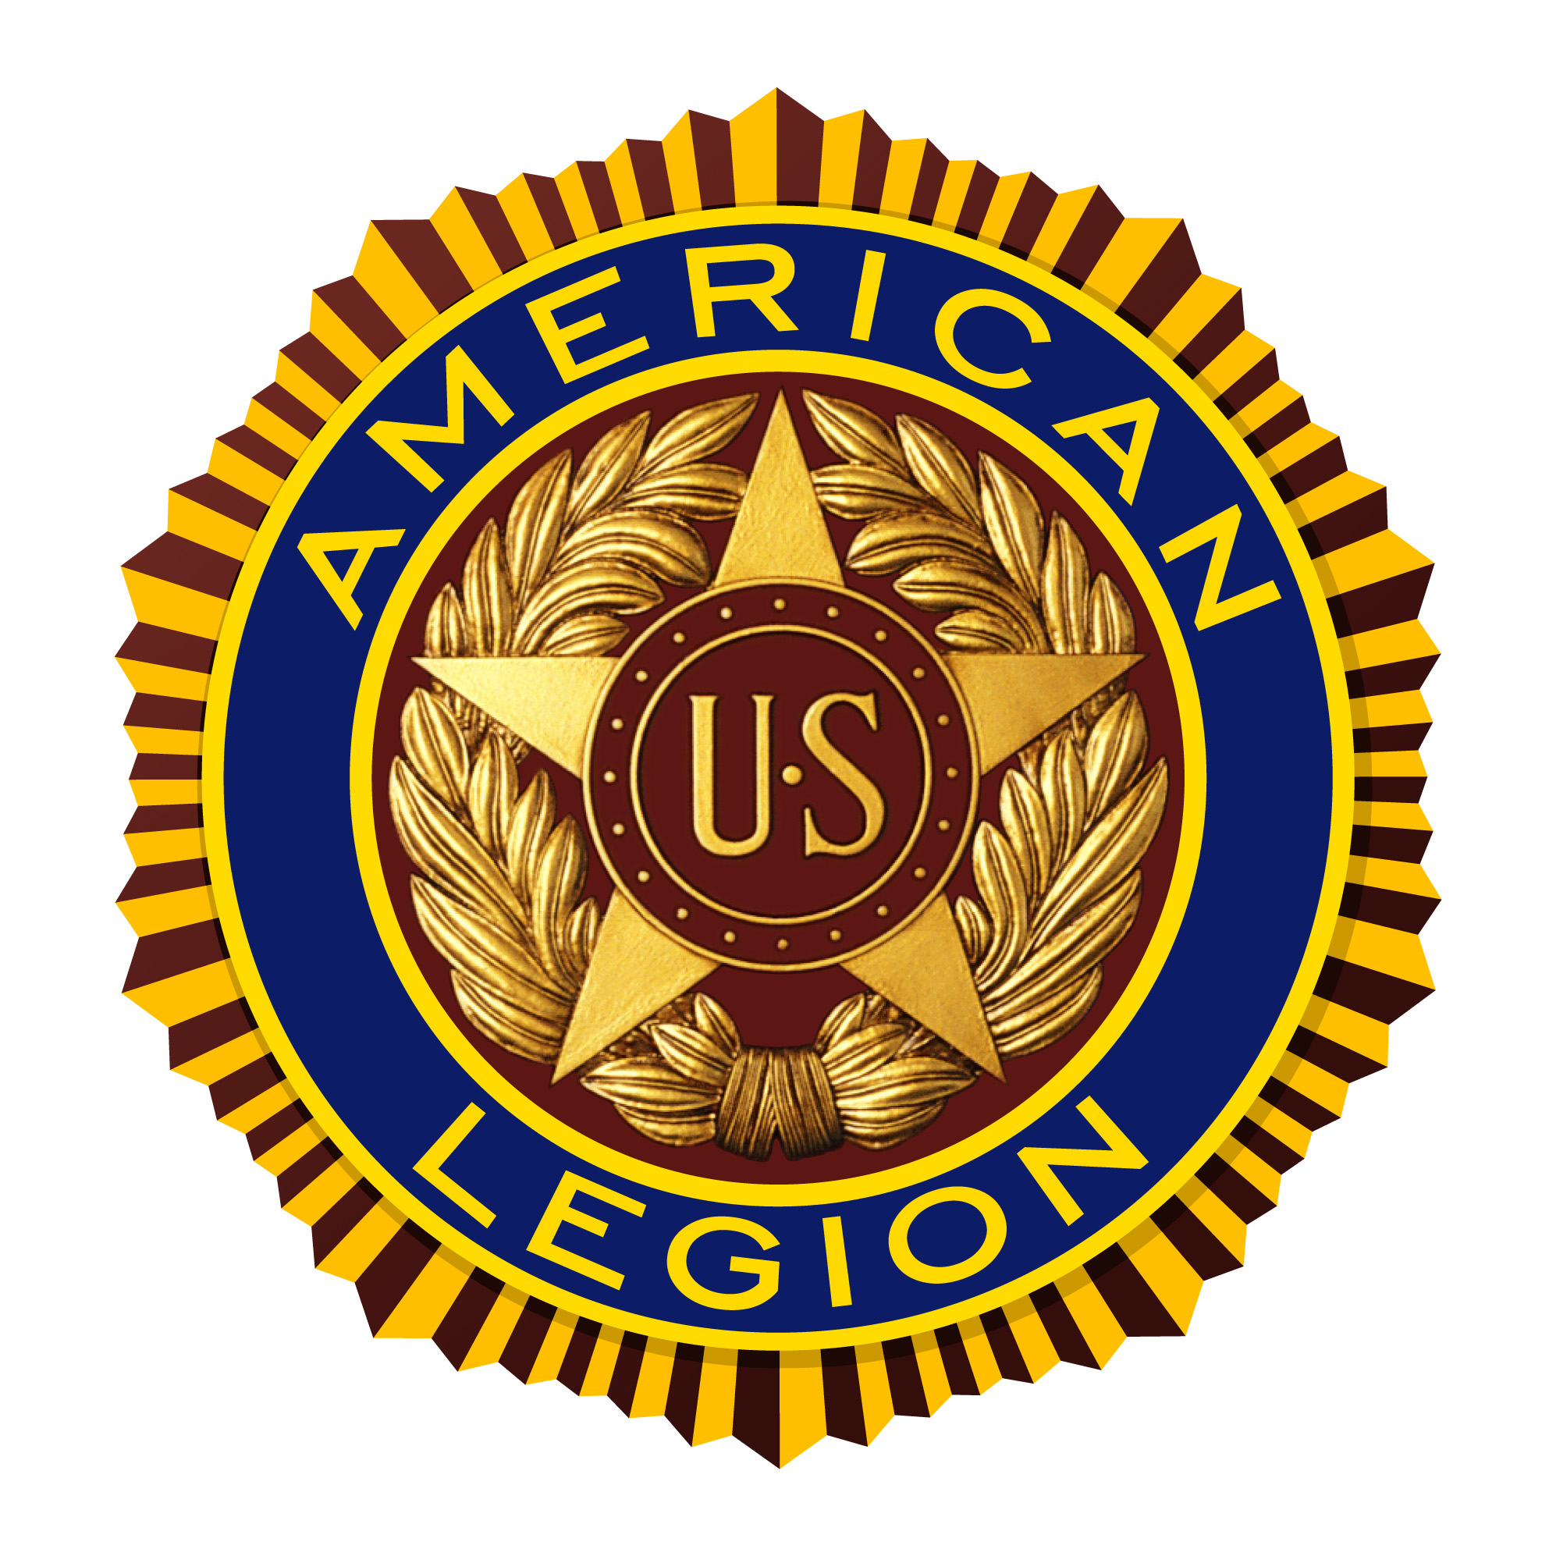
Legion Jubilee
Sponsored by
The American Legion
William M. Randolph, Post 593
Converse, Texas 78109
(210) 658-1111 — www.Post593.org

Converse City Park
June 6—8, 2008

Friday, June 6  4pm—Midnight | Saturday, June 7  8am—1am | Sunday, June 8  Noon—6pm

∗ Carnival Rides and Games  ∗ Live Entertainment: 3 Bands  Friday & 7 Bands Saturday  ∗ Food, Soft Drinks, & Beer Booths  ∗ Arts and Crafts Fair  ∗ Community Yard Sale  ∗ Health Fair & Blood Mobile  ∗ Car and Motorcycle Shows  ∗ Motorcycle Run  ∗ Sanctioned BBQ Cook-Off  ∗ Large Raffle  ∗ Face Painting  ∗ Martial Arts Demonstration  ∗ Dance Demonstrations  ∗ Fire Department Demonstration  ∗ Flag Disposal Ceremony  ∗ Dunking Booth  ∗ Converse Animal Shelter  * Converse Police Dog Demonstration  * Much, Much More! | Band Schedule  Friday  6—8pm  Tina Y Grupo Tormenta (Tejano)  8:30-10:30pm  Ashlee Rose (Country Rock)  10:45—11:45pm  Jet City Rotation (Rock)  Saturday  Noon-1:30pm  Chad Johnson & Fiddler (Country)  2-3:30pm  Emmerson Biggins (Country)  3:45-5pm  Three Kisses (Pop)  5:15-7pm  Tina Y Grupo Tormenta (Tejano)  7:15-9:15pm  Playin’ Sixx (Country)  9:30-10:45pm  Dick Wiggler & The Cattle Guard  (Country)  11pm-12:45am  Jet City Rotation (Rock)

We Would Like to Thank Our Sponsors:
Yamaha of San Antonio Randolph Field Realty
Sportsman’s Bar Sounds Good Entertainment Texas Pride BBQ

Free Admission & Parking! Open to the Public!

