American Legion Jubilee
Motorcycle Run & Show
Saturday, June 7th, 2008
Converse City Park

Five Entry Categories For Motorcycle Show:

Stock, Modified Stock, Custom, Vintage & Sport

Trophies for first and second place for each category!

Best of Show and People’s Choice Award.

Motorcycle Show: $15 pre-registration per bike. $20 after May 23rd, 2008.

Motorcycle Fun Run

First bike out at 10:00 a.m., last bike out at Noon. Last bike in by 3:30 p.m.

Cash prizes for each of 5 stops. $15 for Riders and $10 for passengers.

Live Bands Friday & Saturday Evening – Food and Beverage Booths – Carnival

Sponsored By:  American Legion Post 593  326 West Legion Drive  Converse, TX 78109  (210) 658-1111  http://www.Post593.org | Patch With Inaugural Rocker included!!  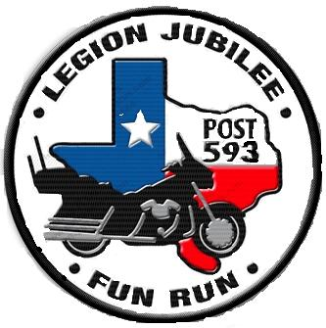  

LEGION POST 593 BIKE SHOW / RUN REGISTRATION FORM
Saturday, June 7th, 2008 – Converse City Park

Motorcycle Fun Run: Yes / No If Yes, Passenger: Yes / No Bike Show: Yes / No
If Yes, Make/Model/Year Class
____________________________________________________________________________________
Name ____________________________________________________________________________________
Address/City/Zip ____________________________________________________________________________________
Phone: Email Address: ____________________________________________________________________________________

Pre-registration by May 23rd, 2008
Bike Run: Rider only: $15, Rider & Passenger: $25
Bike Show: $15
Please fill out this form and mail form & payment to:
(Please Make Check payable to: Post 593 Bike Show/Run)

American Legion Post 593
c/o Jubilee Bike Run/Show
326 West Legion Drive
Converse, Texas 78109

Phone: (210) 658-1111
Website: www.Post593.org

