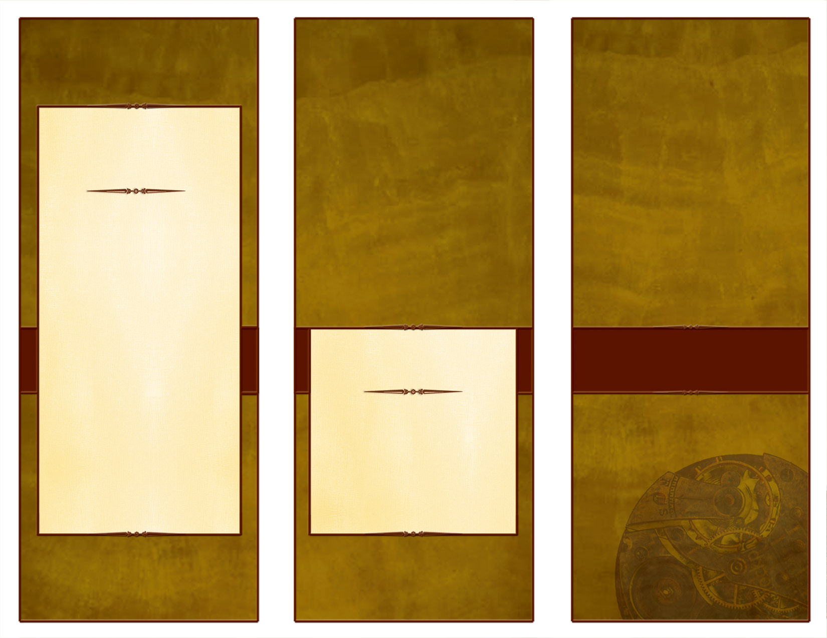
The American Legion
William M. Randolph Post 593
Ph 210.658.1111

326 West Legion Drive
Converse, TX 78109

www.Post593.org
www.ALR593.org
Email: Post593TX@yahoo.com

Our American Legion Post is in the process of raising funds for a new Post Home and we need your help. Within these pages you will find several, but not all, of the programs and institutions we support. Please take the time to look through this material and decide to help us. We can use not only your financial support, but also your time, talents, and encouragement. Our American Legion family includes Legionnaires, Auxiliary, Sons of the Legion, and Legion Riders. Consider this an invitation to become involved and make a difference in people’s lives.

American Legion Post 593

Converse, Texas

“We Put Converse on the Map”

We Need
Your Help!

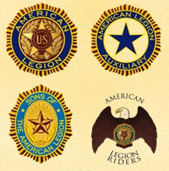

The American Legion
William M. Randolph Post 593

Please visit us on the web at www.Post593.org or email us at: Post593TX@Yahoo.com.
Thank you for taking the time to read this. We look forward to working with you in supporting our community together.

We Need Your Help

To Continue Our Service…

“Still Serving America”

Children & Youth Programs

Scholarship & Financial Aid

Veterans Legilastion & Benefits

National Security & Protection of Our Flag

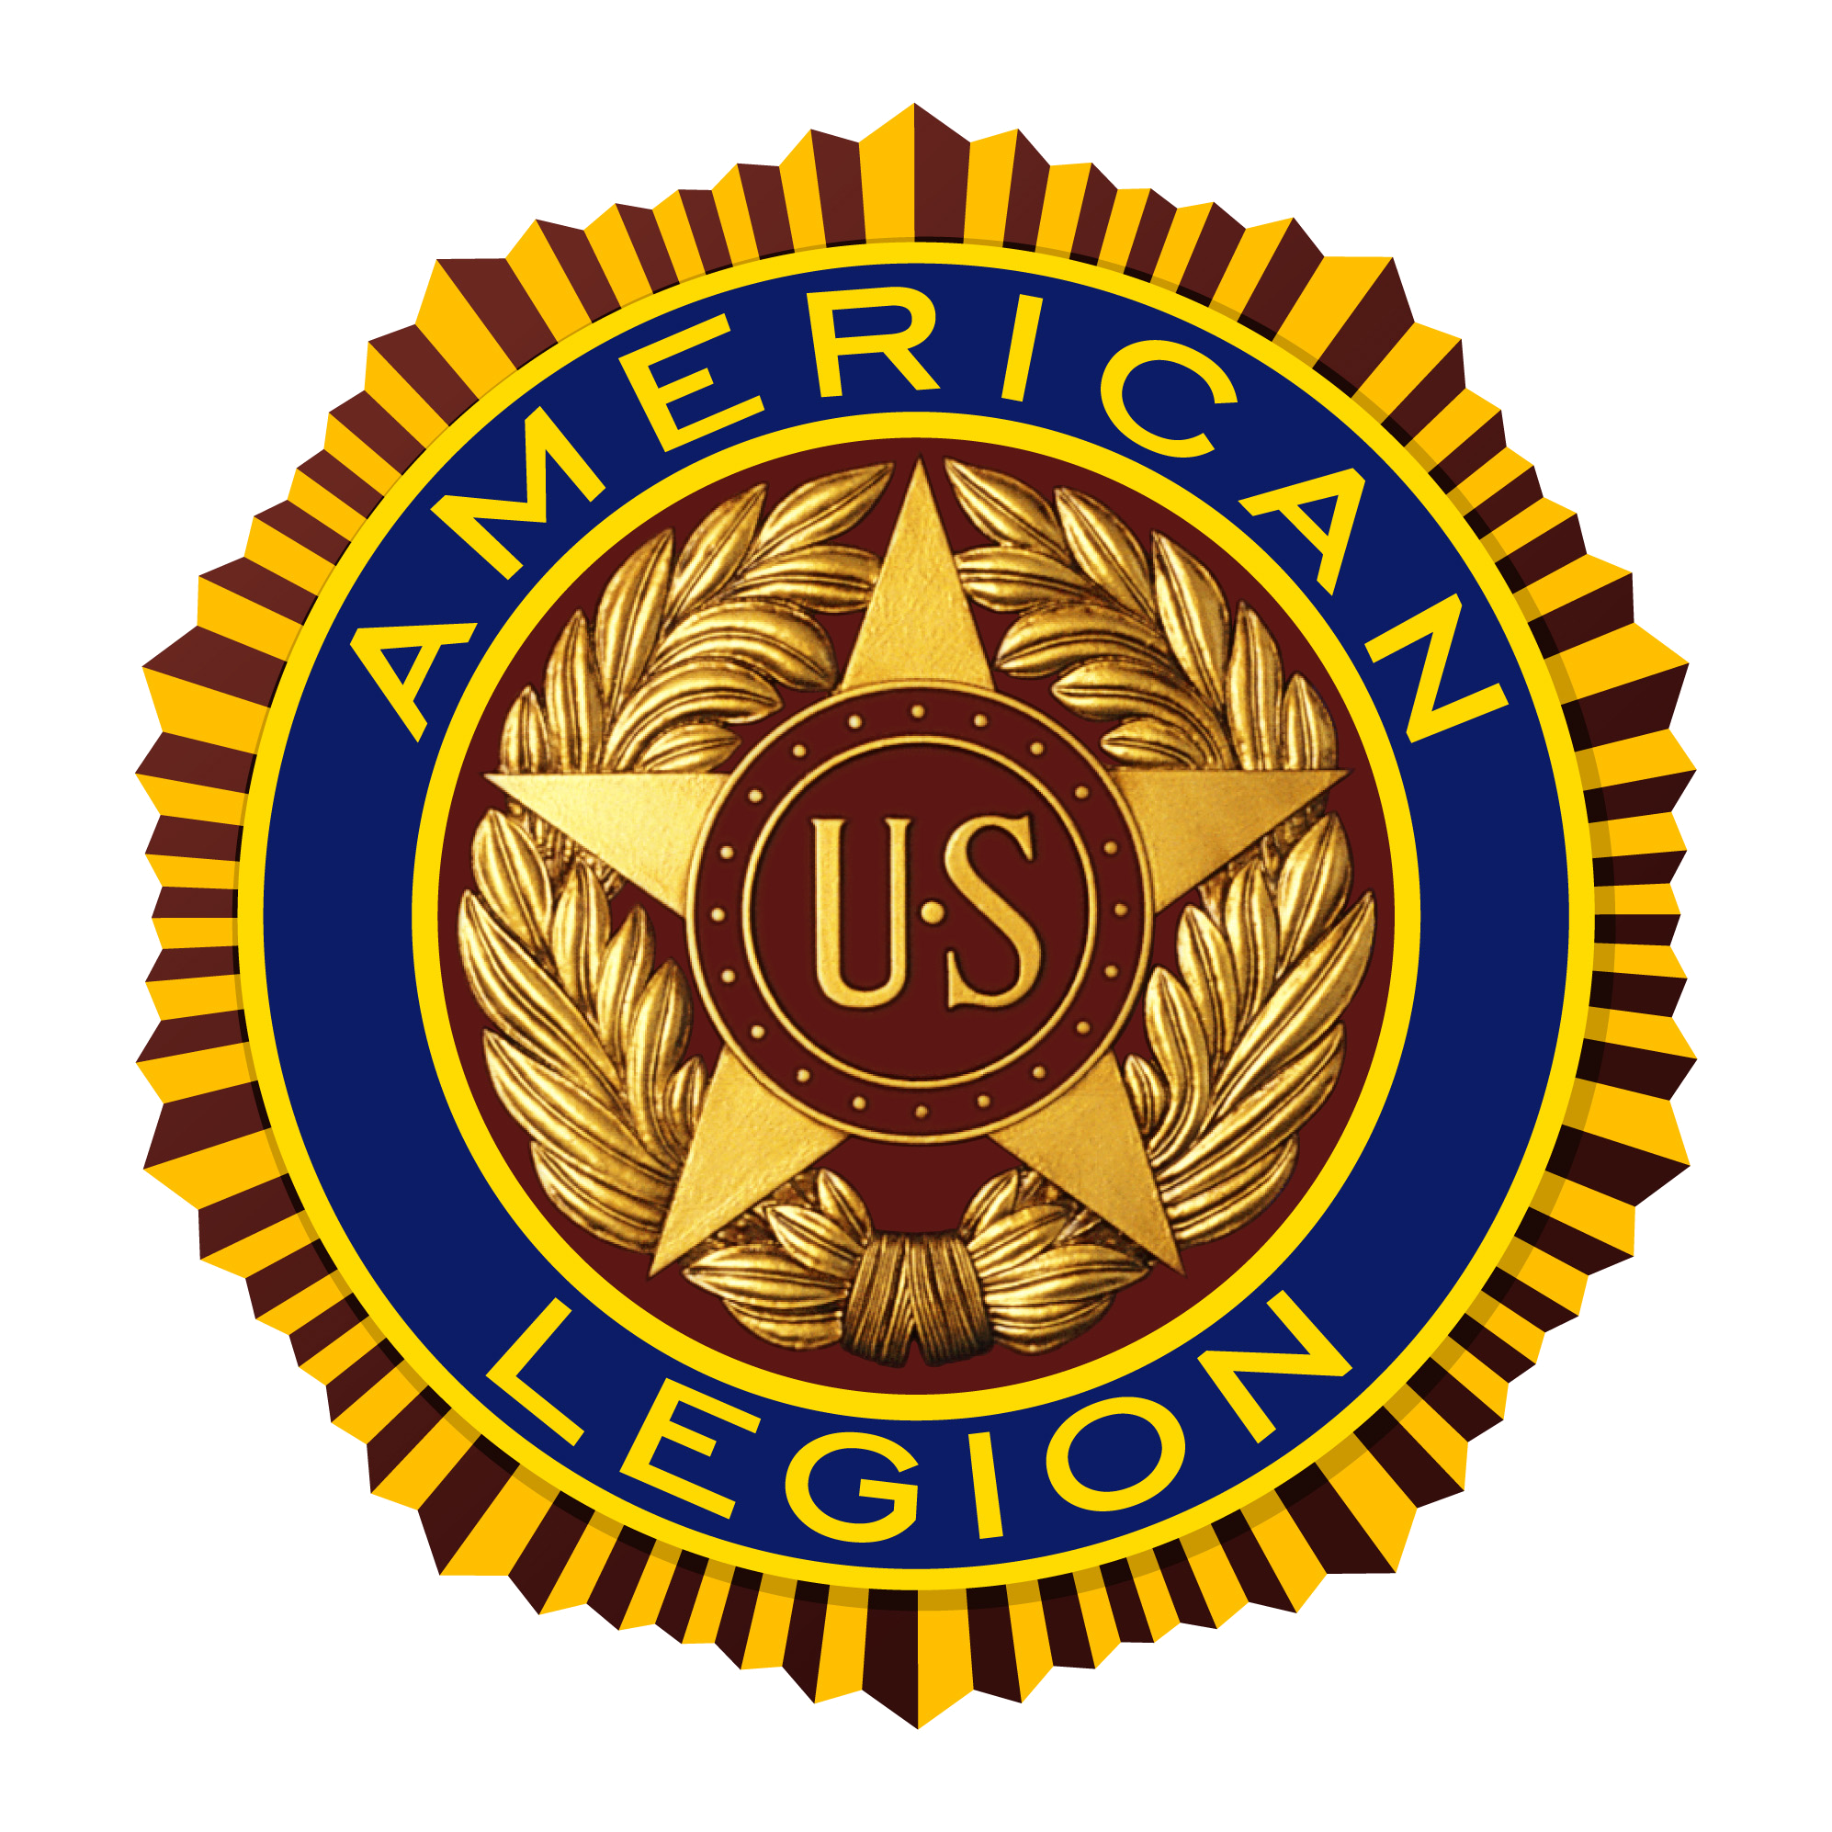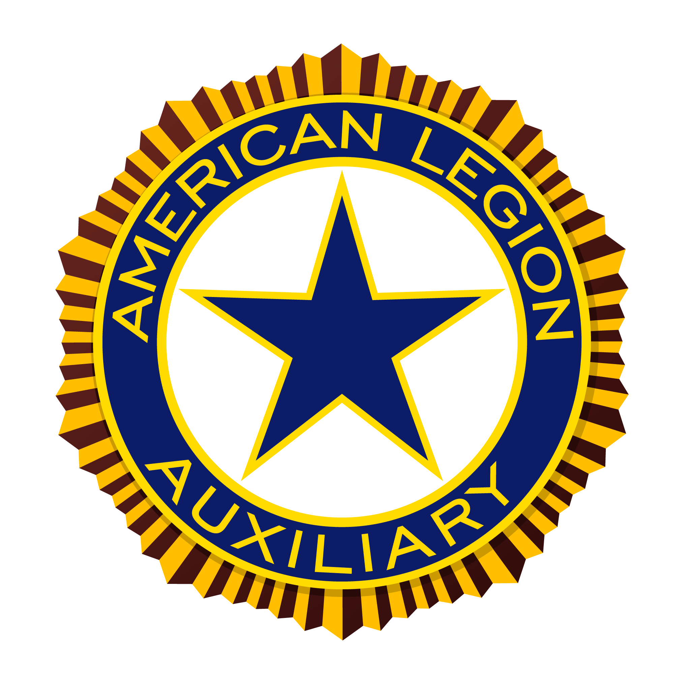

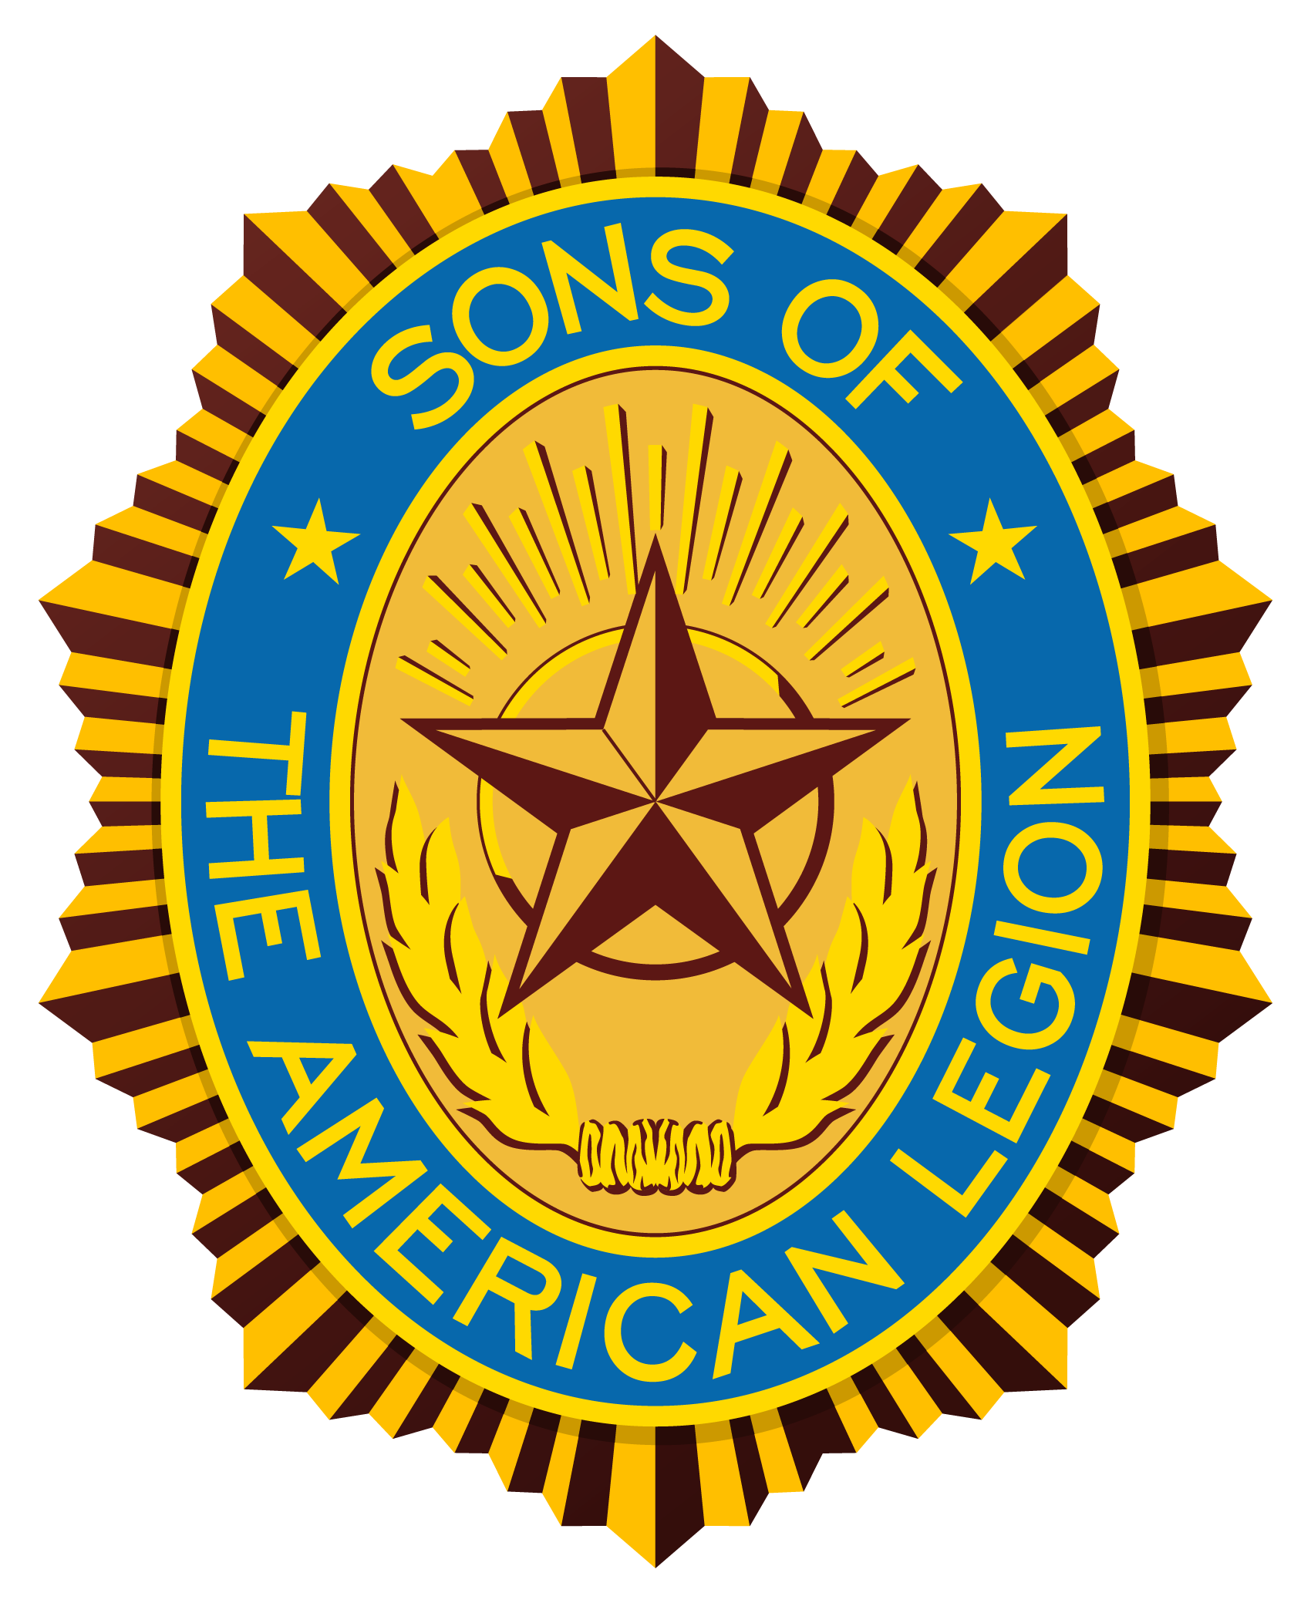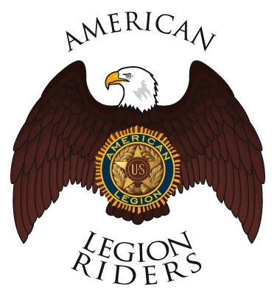
Our local American Legion Post is raising funds for a new building. Our current building is beginning to fall apart. By building a new Post Home, we will be able to increase the already outstanding support we currently provide to veterans, their families, and the local community. In the last year alone we have donated over $60,000 and over 11,000 man hours to the local community. We have also provided the following services to the local community for more than 30 years:
- Veterans
  - Hospital Visitation
  - Soldiers Family Assistance Center (SFAC)
  - Lonesome Dove
  - Nursing Home Visitation
  - Legacy Scholarship Program
  - Fisher House
  - Operation Wounded Warrior
  - Patriot Guard Missions
- Neighbor-Helping-Neighbor
  - Boys State
  - Girls State
  - Oratorical Contest
  - Junior ROTC
  - Boy Scouts
  - Flag Program
  - Food Baskets for Needy
  - Scholarships
  - Adopt-a-Highway
  - Clothing Donations
  - Re-cycle Program
  - Parks and Recreation Assistance
  - Meeting Space for Community Organizations



