American Legion Post 593
Car Show
Sunday, June 8th, 2008
Converse City Park
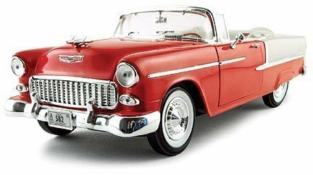
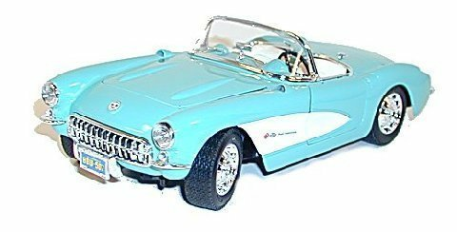

Class A: 1948 And Older Original Cars And Trucks. Must Be Stock Appearing, Have Period Style Wheels, Tires, Paint And Interior, Original Type Engine And Running Gear.  Class B: 1949 Thru 1979 Original Cars And Trucks Same As Class A  Class C: Street Rods -1948 And Older Cars And Trucks Can Have Any Combination Of Modifications To Body, Chassis, Power Train, Suspension, Interior And Paint.  Class D: Street Machine / Custom - 1949 Thru 1979  Same As Class C  Class E: Modified -1949 Thru 1979 Cars And Trucks Power Train Must Be Similar To Factory Installed For Model Year. Can Have Any Combination Of After- Market Or Factory Bolt-On Performance And Appearance Features, Such As, Wheels, Tires, Intake/Exhaust Paint. No Custom Body Work Or Custom Interior. Roll Bars Permitted But No Roll Cages. | Class F: Factory Hi-Performance 1964 Thru 1979 [Muscle Car] Sample; Mustang, Camaro, Firebird, GTO, Challenger, Cuda, El Camino, Etc. Must Be Stock Appearing With Minor Mods Allowed.  Class G: Foreign – Open Any Car Or Truck Manufactured Outside The USA, Stock Or Modified  Class H: Competition – Open Any Car Or Truck Used In Motor sport Competition That Is Not Legal To Drive On Texas Roads.  Class I: American Cars & Trucks 1980 thru 1988  
There will be Judging for Best of Show and People’s Choice Award. Each Category Will Have a 1st and 2nd Place Winner.  Gates for car show open 9:00 a.m.  Registration will close at Noon  Participant ballots must be turned in by 2:00 p.m.  One ballot per entry | Sponsored By:  American Legion Post 593  326 West Legion Drive  Converse, TX 78109  (210) 658-1111
Visit us on the web at: www.Post593.org
LEGION JUBILEE CAR SHOW REGISTRATION
Converse City Park
Sunday, June 8th, 2008
Make/Model/Year _________________________________________________________________________
Class ____________________________________________________________________________________
Name ____________________________________________________________________________________
Address/City/Zip ___________________________________________________________________________
Phone: ____________________________________________________________________________________

Please fill out this form and mail form & payment of $20.00
American Legion Post 593
c/o Sharon Rector
326 West Legion Drive
Converse, Texas 78109
210-658-1111
(Please Make Check payable to: Post 593 Car Show)

